For Linux System:
1. Create a virtual environment named venv
python3 -m venv venv
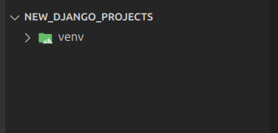

2. Activate the virtual environment
source venv/bin/activate
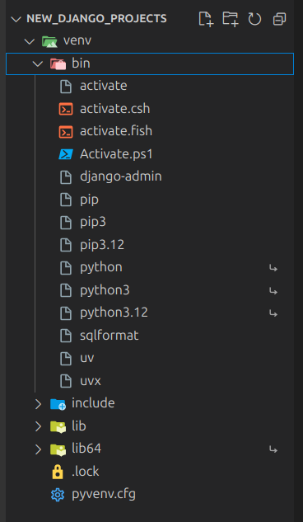

3. Install Django using uv
uv pip install Django

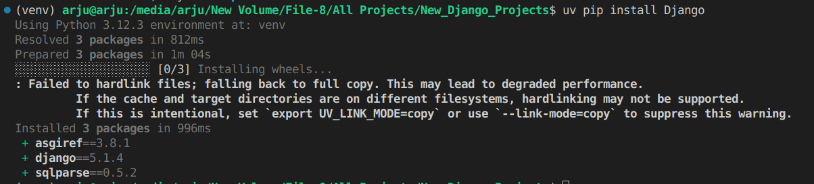

4. Create Django Project named djangoproject
django-admin startproject simple-django-project

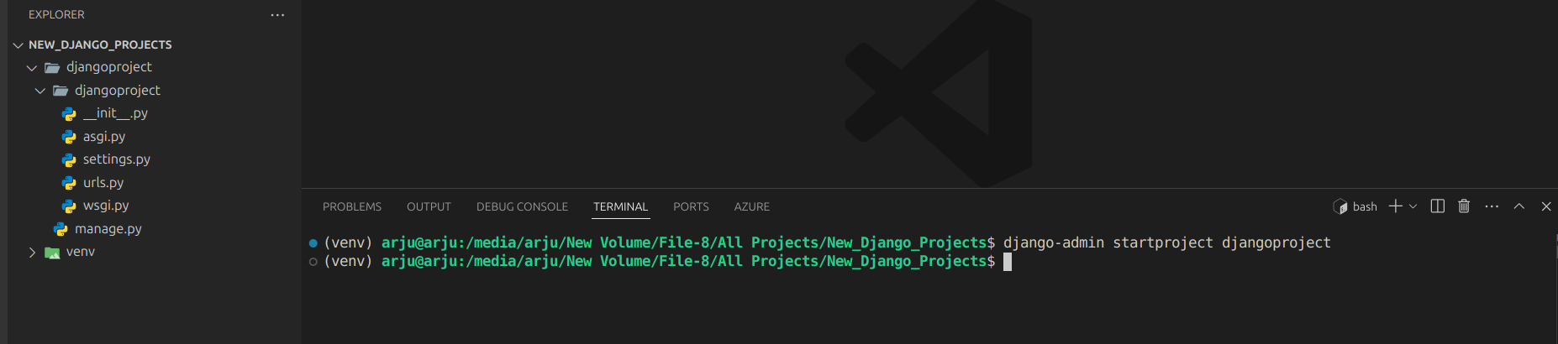

5. Go to djangoproject directory
cd djangoproject/

6. Run the project
python manage.py runserver

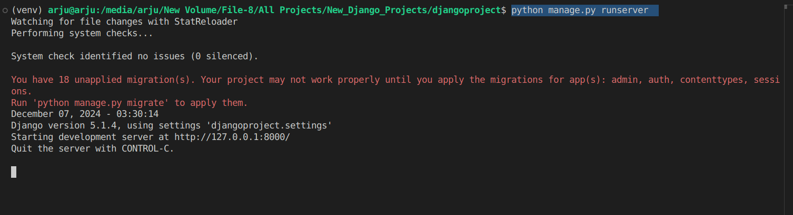

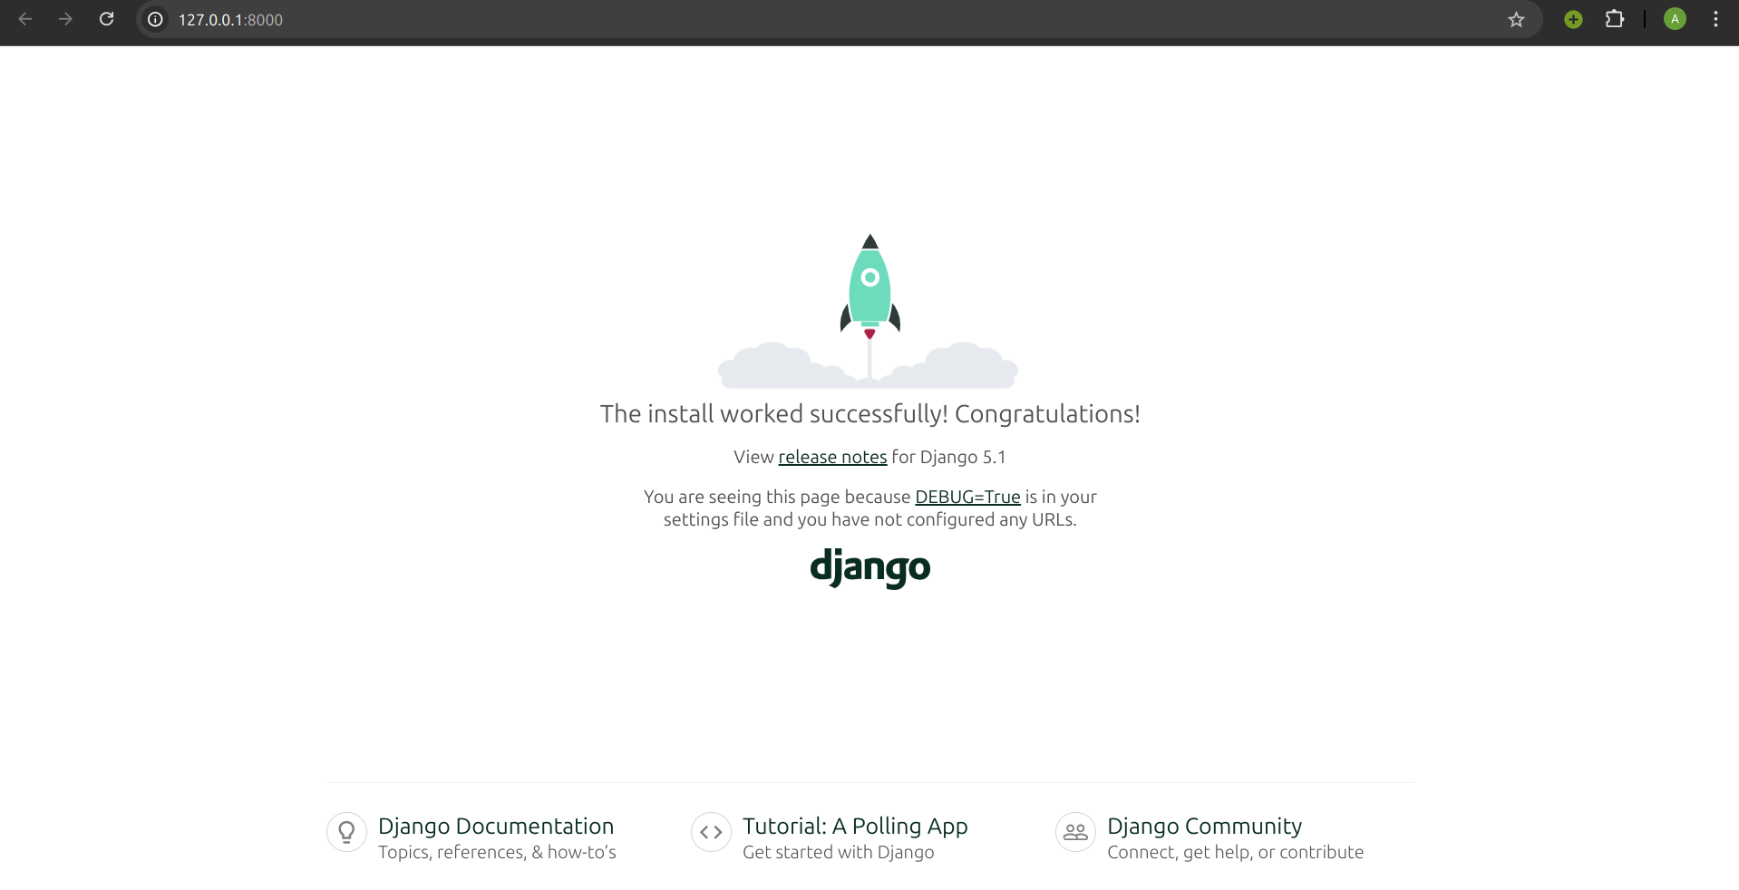
7. Create a file name views.py under the main project directory name djangoproject
8. Create a app named products
python manage.py startapp products

9. Add Tailwind in a django project
uv pip install django-tailwind

uv pip install 'django-tailwind[reload]'

python -m ensurepip –-upgrade

python -m pip install –upgrade pip

python manage.py tailwind init

Add this line after install app from settings of the djangoproject
TAILWIND_APP_NAME = 'theme'
INTERNAL_IPS = ['127.0.0.1']

python manage.py tailwind install

python manage.py tailwind start

Add this in settings under MIDDLEWARE

'django_browser_reload.middleware.BrowserReloadMiddleware'

python manage.py migrate

create super user
python manage.py createsuperuser

change password
python manage.py changepassword <username>

python manage.py makemigrations <appname>
Project Cycle

1. Create app
2. Add in Main Settings Install APP:[
‘app name’
]
3. Under app create model
4. Register the model in APP admin file
5.

